DR WHO?

Chinese state media quotes fake ‘Swiss biologist’ in desperate propaganda effort to discredit Wuhan lab leak theory.

CHINESE state media has quoted a "Swiss biologist" that appears not to exist in an apparent attempt to discredit claims that Covid came from a lab.

Swiss scientist “Wilson Edwards” was reported to have accused the USA of pressuring the World Health Organisation to investigate the leak theory.

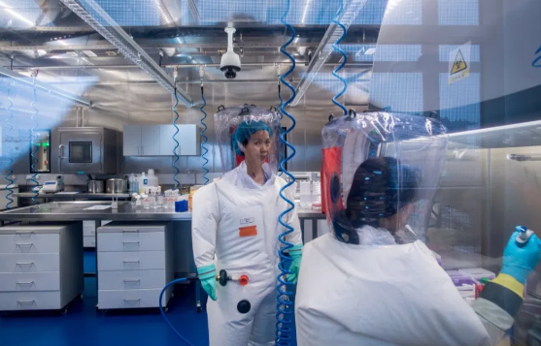

The People’s Daily, China Daily and the state-run CGTN television network widely quoted the “scientist” rubbishing the theory - which he said was only designed to increase American influence.

He apparently told The People’s Day: “Unfortunately, Washington’s re-entry has brought geopolitical competition to the science-spearheaded world body.”

Dr Wilson allegedly even expressed “the disappointment of the international scientific community toward the US”.

The Swiss embassy later said there was no citizen by that name and that it could find no academic articles by him.

A spokesman told the Times: “If you exist, we would like to meet you! We need transparency to understand and know or find the origins of this virus.

WHO Director General Dr Tedros Adhanom Ghebreyesus, 56, speaking at a [G7 summit](https://www.thesun.co.uk/topic/g7-summit/) briefing, said the possibility of it coming from a lab leak hadn’t been ruled out and that there had not been enough “transparency and co-operation” from China in the initial stages of the investigation. (“There were difficulties in data sharing, especially raw data… (we) hope the next phase there will be better cooperation and transparency.”)

And an expert has now warned China could launch its own manhunt to find the "culprits" behind a possible leak - and execute them.

Ross Terrill, a research associate at Harvard's Fairbank Center for Chinese Studies and the author of 11 books on China, said President Xi Jinping might acknowledge the possibility of a "freak lab accident" to save face.

"China might find culprits for the mistake in the lab and execute them, to show Beijing’s pure intentions," Terrill told The Sun.

**Link:** <https://www.thesun.co.uk/news/worldnews/15846501/china-quote-fake-biologist/>

**Author:** [**Adriana Elgueta**](https://www.thesun.co.uk/author/adriana-elgueta/)